Background

Whether financial, political or social – data’s true power lies in its ability to answer questions definitively. So, for this assignment, based on what I’ve learned about Python requests, APIs, and JSON traversals, I will answer a fundamental question: “What’s the weather like as we approach the equator?”

Method

I will use various Python scripts to visualize the weather of 500+ cities across the world of varying distance from the equator.

The objective here is to create a representative model of weather across world cities and showcase the following relationships:

1. Temperature(F) vs. Latitude
2. Humidity (%) vs. Latitude
3. Cloudiness (%) vs. Latitude
4. Wind Speed (mph) vs. Latitude

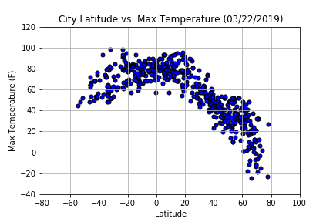

Analysis:

As expected, the weather becomes significantly warmer as one approaches the equator (0 Deg. Latitude). More interestingly, however, is the fact that the southern hemisphere tends to be warmer this time of year than the northern hemisphere. This may be due to the tilt of the earth.

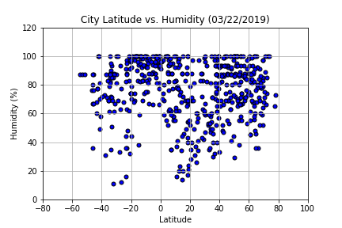

Analysis:

By definition, humidity is the amount of water vapour present in the air. Warm air tends to hold more moisture than cool air. With this in mind, it explains the relatively high humidity level near the equator averaging 76%. The problem with high humidity is that it makes hot weather more unbearable. When traveling anywhere near the equator, you will most likely start feeling hot and sticky and probably a little uncomfortable.

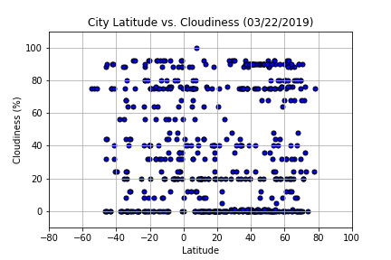

Analysis:

There is no strong relationship between latitude and cloudiness. However, a strong band of cities sits at 0% cloudiness. Nice and sunny days for most places!

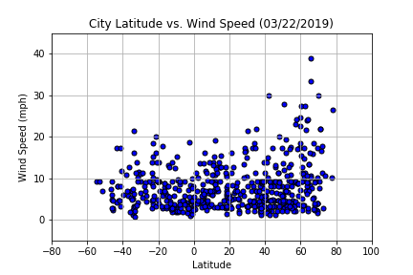

Analysis:

There is no strong relationship between latitude and wind speed. Most of the cities have a wind speed of less than 10 mph. However, in northern hemispheres there is are some cities with over 20 mph of wind.

Conclusion:

So, going back to the question: “What’s the weather like as we approach the equator?” Based on randomly selected cities across the globe and as shown in the previous four scatter plots, it will feel hotter. Mainly due to humidity levels being higher. The relative high humidity will affect your body’s cool-down mechanism. You must give your body a few days to adjust to the new environment. (it happens to me every time I travel to Nicaragua 😊) Furthermore, with an overall average of 40% cloudy skies you might want to include sunblock. And no worries for the wind blowing off your cap or hat since most cities have a wind speed of less than 10-15 mph. Surely, the breeze and getting plenty of fluids will be welcoming with such a hot weather.